Everything You Need to Know About

Middle School…

Ashe County Middle School Home Page

This planning guide belongs to:

________________________________

What Happens at Middle School?

You might be wondering, “How different is middle school from elementary school?” Well, we won’t lie to you—it’s pretty different. While this is exciting, it also can be scary, and it will take time to adjust. This planning guide will help you prepare for some of the changes and choices you will experience as a middle school student.

Important Words to Know:

* Encore Rotation: This is a fancy word used for “electives.” You will be scheduled for Art, Agriculture, Project Lead the Way, Exploring Business Technology, Spanish, and Career Decisions. Each of these classes will last one quarter, which is about 9 weeks. So don’t worry if you find you aren’t very interested in one of them—because in 9 short weeks, it will be time to switch classes!
* Core Classes: These classes are: Math, Language Arts, Science, and Social Studies. Every student takes these classes, and they last all year.
* Band & Chorus: If you choose to take band or chorus as an elective (instead of the encore rotation), you may choose to make a year-long commitment or you can sign up for just one semester. You may not have both band and chorus.
* Block: The set amount of time in which a class is taught. At Ashe County Middle School, we have 5 blocks in one day. Each encore class is about 45 minutes, and each core class is 70 minutes.
* Lunch: Students eat in the cafeteria in one of three lunch periods. Unfortunately, we can’t guarantee that you will have the same lunch period as your friends, and this may be hard at first, but this is a time to meet new people.
* Teams: Of course we have sports teams at ACMS, but this is something different. At ACMS, students are divided onto academic teams. The 7th grade teams are the Cheetahs, Lions, and Tigers.
* PE: PE is required for all students at ACMS. PE is a semester long. Everyone must dress out and swim during PE. Remember to take home dirty PE clothes to wash them! PEEW!!

What to Expect

In middle school you change classes every block, have more homework, and are expected to take on more responsibilities than ever before. On top of all of that, you may be dealing with changing friendships and changing bodies. YIKES! How in the world will you manage all of that?? The truth is, some days will be harder than others. But if you know this, and are prepared for it, then you’ll be ready to handle all of these new changes and choices.

Lockers

At ACMS, every student is assigned a locker. Book bags must be kept in your locker. You will carry only what you need for each class and can return to your locker between classes to get what you need for your next class. Locks are not necessary. ACMS is a safe place for you and your belongings. No rolling book bags!

Planners

All students are given a planner on the first day of school and are shown how to use them. Planners are useful to students as they learn to stay organized, keep up with assignments and complete homework. Planners should be used on a daily basis. If your student loses their planner, there will be a $6 charge for a new one.

Schedule

You will receive your schedule at orientation (if you attend), and on the first day of school. Here are a few things you may be wondering about your class schedule:

* We do not change schedules so you can have classes with your friends
* We do not change schedules so you can have lunch with friends
* We do not change schedules because you don’t like a teacher

You may feel free to speak with a counselor about your schedule if:

* You have a question about your core classes
* You are not scheduled for 4 core and several encore classes
* You accidentally got scheduled for the same class twice
* You want to be in band or chorus but got scheduled for Encore rotation (or vice-versa)

There are other reasons to request a schedule change, and if you have a question about it, please ask. We tend to keep all schedule changes to the first week or so—then you are expected to stick with the classes you have.

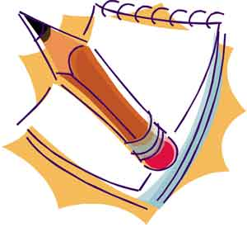

Staying Organized

Keeping yourself organized is the ticket to success in middle school. Here are a few tips to get you started:

Notebook/Binder: You will have 4 core plus encore classes each day. You should have a system for organizing these classes with either binders or notebooks. Make sure there are pockets or folders for loose papers. You might even have a section for “completed homework” that needs to be turned in. Whatever system you choose, make sure it is one that you will be comfortable using.

Planners: Because you have more classes in middle school, and more work to complete, it is very important to keep it all straight. Each student will be given a planner to write down homework assignments, test dates, project due dates, etc. USE YouR PLANNER! Make your planner part of your daily routine. Finally, as important as it is to write things down in your planner, don’t forget to take it back out of your backpack and LOOK AT IT when you get home. Planners are also full of valuable information about dress code, attendance, the grading scale, and cell phones. So if you have a question, you can check the planner for information or ask someone.

Backpack: Make sure your backpack is packed and ready to go each night before you to go to bed. This will save you the trouble of rushing around in the morning, which is usually how you forget things. Also, take time every week to clean out your backpack.



Resources and Where to go for Help



TEACHERS: If you need help with schoolwork, ask your teacher! If you are struggling in class, get help right away! The longer you wait, the harder it is to catch up.

* Find a moment when the teacher is not instructing the rest of the class
* Be specific! Make sure you are clear about what it is you don’t understand. Tell them how they can help you.

Example: “Mr. Smith, can I get some help with ratios?” Remember, teachers cannot read your mind. If you need help, you have to ask for it!

COUNSELORS: Stop by the office and see the counselor. Counselors can help with:

* School related problems
* Problems with friends
* Family issues
* Personal problems

AT ACMS, we have two counselors, Mrs. Julie Jones, and Mrs. Lynnette Stallings. School counselors are great for helping you come up with a plan, giving suggestions when you have problems, or answering questions.

PARENTS: Sit down with a parent, or an adult that you trust, and explain that you’re having a hard time at school. Let them help you make a plan to get help.

* Ask a parent or guardian to check your planner
* Parents can help you study for tests
* Your parents can help you get connected with the help you need!

Gear-UP: This is an exciting resource for middle school students, families, and schools. As a Gear -Up school district, our students will receive many resources and services over the next seven years to help them prepare for success in life after high school and in college. Ms. Karee Mackey is the Gear-up Coordinator at ACMS.

Resources and Where to Go For Help (Continued)

4-H AFTERSCHOOL: Afterschool services are available every weekday from 3:15-6:00pm. Afterschool tutoring is available from 3:15-4:15 on Mondays, Tuesdays, and Thursdays. You must complete an application in order to stay in the afterschool program. There is no charge for any afterschool service.

Top Dog Clinic Ashe School Based Health Center: We are pleased to offer the services of Ashe School Based Health Center (Top Dog Clinic) on the campus of our middle school. The clinic offers services to all seventh and eighth grade students enrolled in school with signed parental permission on file. Services include preventative and acute medical care, health education, substance abuse prevention and intervention, nutrition and immunizations. The clinic is open Monday-Friday from 8am-3:30pm.

PTO: Parents are encouraged to participate with our PTO. The Parent Teacher Organization works together with the faculty, staff and administration at ACMS to support the needs of the school. The Advisory Committee is elected by the members at large to conduct business concerning school improvement.



Make Time for Homework



* Set up a special time each day and stick to it! If you do not have a written assignment due, take time to do your “at home” reading (part of your Language Arts grade) or review notes for a test. If you can do anything in advance, do it!
* Set up a special place to study. Make sure it’s away from the TV and any distractions that may bother you. If you do not have a place like this at home, you can stay afterschool to complete homework.
* Find out if a teacher is willing to stay afterschool to help you when you are struggling or attend the 4-H After school tutoring held three days each week (Monday, Tuesday, and Thursday from 3:15-4:15pm).
* Break down big projects into steps. Create a timeline and set up your own personal due dates for each step. If you need help doing this, ask a teacher or adult to help you.
* Turn in your homework! You may be surprised to know that a lot of students complete their homework but then lose it or forget to turn it in. Why do all the work, then forfeit the grade? This is another reason to keep your binder and backpack organized.
* Exchange phone numbers with someone in your class. You never know when you might get stuck on a problem or have a question about an assignment.

**Parents: Be prepared to take away privileges (cell phones, ipods, video games, time with friends, etc) when homework is not getting done. Teachers are more likely to spend extra time with a student who is making an effort than a student who consistently fails to complete assignments.**

Friends and Middle School

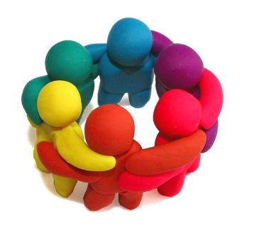

By now you’ve probably heard a lot about how much things change in middle school. This is an exciting time in your life—you are no longer an elementary school kid, you have a lot more freedom when walking around school, you are noticing changes in your body and in your responsibilities. Well, along with all of these other changes, middle school seems to be a time when friendships change as well! There are many reasons for this:

* You will be going to school with 7th and 8th graders from three elementary schools, so there are lots of new people to meet and connect with
* With all of the different teams and activities, you and your friend may find you have different interests
* You aren’t in class with your friend all day
* You may not have lunch with your friend
* We all grow, mature, and change, and oftentimes friends just grow apart at this age

All of these things can make it hard for you to keep the best friend you have had since kindergarten. It can be really painful and hurtful if your friend discovers they have more in common with someone else that they just met. Don’t feel like all hope is gone! There are 500 other students your age at ACMS that are going through the same thing. Certainly someone else is looking for a friend too. This may take a while, and it may mean a few lonely lunches here and there, but keep your head up and have faith. Your next best friend may be just around the corner!

If you find yourself feeling lonely or down in the dumps because you feel a divide between you and a friend, talk to someone about it. Maybe a parent, teacher, or counselor can help. It helps to share how you are feeling.

Remember: Talking about friendship issues with other students can make things worse. Middle school is a place where rumors and gossip grow and spread like wildfire at times. So be careful about what you say about and to other people!

All About Encore Rotation, Band, and Chorus

At ACMS, you have choices when it comes to your Encore classes. You can choose band, either half a year or whole year, or you can take chorus, also either half year or whole year. However, you can’t take both band and chorus…you have to choose. If you don’t want to take either band or chorus, you take classes in the Encore rotation. The classes included in this are: Art, Spanish, Project Lead the Way, Exploring Agriculture, Career Decisions, and Business Technology. You don’t choose the classes you want to take in Encore Rotation because you will spend about 9 weeks in each of them. Curious about these classes…? Here’s a little information about each of them…

Art

This course is designed to expose students to lots of different techniques and mediums. Paper mache, oil pastel, and paint are just a few of the mediums that will be explored. Hard work is expected, and you must have a creative imagination.

Exploring Career Decisions

This class is designed to foster an investigation of self and the world of work which should lead to meaningful career planning. Students enrolled in this class should gain an understanding of the relationship between a job and a career, the reasons why people work, how work influences lifestyle and identity, and how work provides a sense of satisfaction and keeps the economy strong.

Spanish

Students learn the basics of the language (alphabet, pronunciation, greetings, numbers, the family, the class, actions, adjectives, time…). The emphasis is placed on the development of the four skills (listening, speaking, reading, and writing.) The program also focuses on culture. The students are introduced to the diverse culture of the Spanish speaking world. They develop appreciation for the cultural perspectives, practices, and products of different cultures.

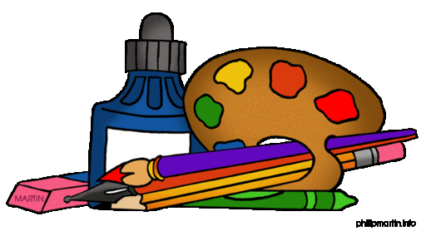

All About Encore Rotation, Band, and Chorus (continued)



Grade Project Lead the Way: Design & Modeling

Students apply the design process to solve problems and understand the influence of creativity and innovation in their lives. They work in teams to design a playground and furniture, capturing research and ideas in their engineering notebooks. Using Autodesk® design software, students create a virtual image of their designs and produce a portfolio to showcase their innovative solutions.

Band

Starting next year, students will have the unique opportunity to begin playing a band instrument! This is an excellent chance to begin and exciting and educational experience. Band meets every day for lessons and practice. The following instruments are taught: flute, clarinet, alto saxophone, trumpet, trombone, and drums. It is a golden opportunity for creativity and learning that will last a lifetime! Students must rent or purchase their own instrument.

Exploring Agriculture

This course introduces students to the industry of agriculture. Topics include animal science, agriculture science, food science, plant science, agriculture issues, stewardship, consumer agriculture and careers in agriculture.

.

Chorus

This course is a select group of students representing Soprano, Alto, Tenor and Bass or a combination of two or more of these parts. Students will grow in their knowledge of musicianship. Acceptable choral behavior is required along with participation in ALL performances and rehearsals.



Real Questions from Real Students

Question: Will we have recess or time to play with our friends:

Answer: Not exactly. There will be some time to socialize during lunch and there are 5 minutes between classes to use the bathroom or say a quick hello to someone.

Question: Are 8th graders mean?

Answer: As a general rule, no. They tend to hang out with other 8th graders, and 7th graders don’t have lots of contact with them. The two grades are on separate halls in the school building and seldom see each other. Eighth graders may be taller and look older, but they are usually pretty helpful. If someone is harassing or bullying you, tell an adult!

Question: Do I have to take PE, and do I have to swim during this class?

Answer: Yes, you have to take PE, and you have to swim.

Question: Are teachers mean, and is there a lot of homework?

Answer: As a general rule, the answer to both is no. Each teacher is different and has their own rules about what they expect in the classroom. As for homework, depending on how much you get done during class, you might have some stuff to finish up at home. There is always studying for tests, AR reading, and other things.

Question: What if I get lost?

Answer: Well, hopefully you won’t, but if you do, there will be plenty of teachers in the hallways to help you find your way. Try to come to open house so you can get your schedule and find out where your classes are.

Question: Can I take my cell phone or ipod with me to ACMS?

Answer: Yes, you can bring these to school, but they must be powered off during the school day. It is also your responsibility to keep up with these items!

Question: What happens if I get in trouble at ACMS?

Answer: Several different things can happen depending on what you have done. One option is After School Detention (ASD). You would have to stay afterschool for one hour in the afternoon from 3:15-4:15pm. Another possibility is In-School Suspension (ISS) or Out of School Suspension (OSS). Hopefully you’ll never need to know anything about either of these!

Question: Is there a dress code at ACMS?

Answer: Yes, there is a dress code, and it is enforced. This will be covered in detail at Parent Night and Open House. It’s also covered in your student planner. Please ask if you have questions.

Upcoming Events for Rising 7th Graders

What: A parent orientation night about middle school

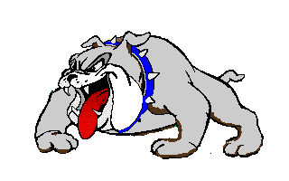

Where: Ashe County Middle

School Cafeteria

When:

What Time:

Come and learn important information for next year!

An event for rising seventh graders to come to the Middle school and play games, tour the school, have a snack, and start making connections for next year!

When: Friday, May 13, 2016

Where: Ashe County Middle School

What Time: Students ride the bus from their elementary school and stay at ACMs from 11am-2pm

Middle School Athletics

Ashe County Middle School encourages all students to participate in our athletic program. Being a participant or supporter of our teams is fun and rewarding. The following sports are offered through the middle school: volleyball, basketball, cheerleading, wrestling, softball, track, soccer, golf, and baseball.

To be eligible to participate a student must:

* Be enrolled in 7th or 8th grade
* Have signed parent or guardian permission
* Have proof of medical insurance
* Have been in attendance at least 85% of the days of last semester
* Must pass 3 of the 4 Core classes and 1 of 2 Encore classes

All sports hold try-outs, and unfortunately not everyone who tries out will make the team. We encourage you to work hard and give it your best shot!



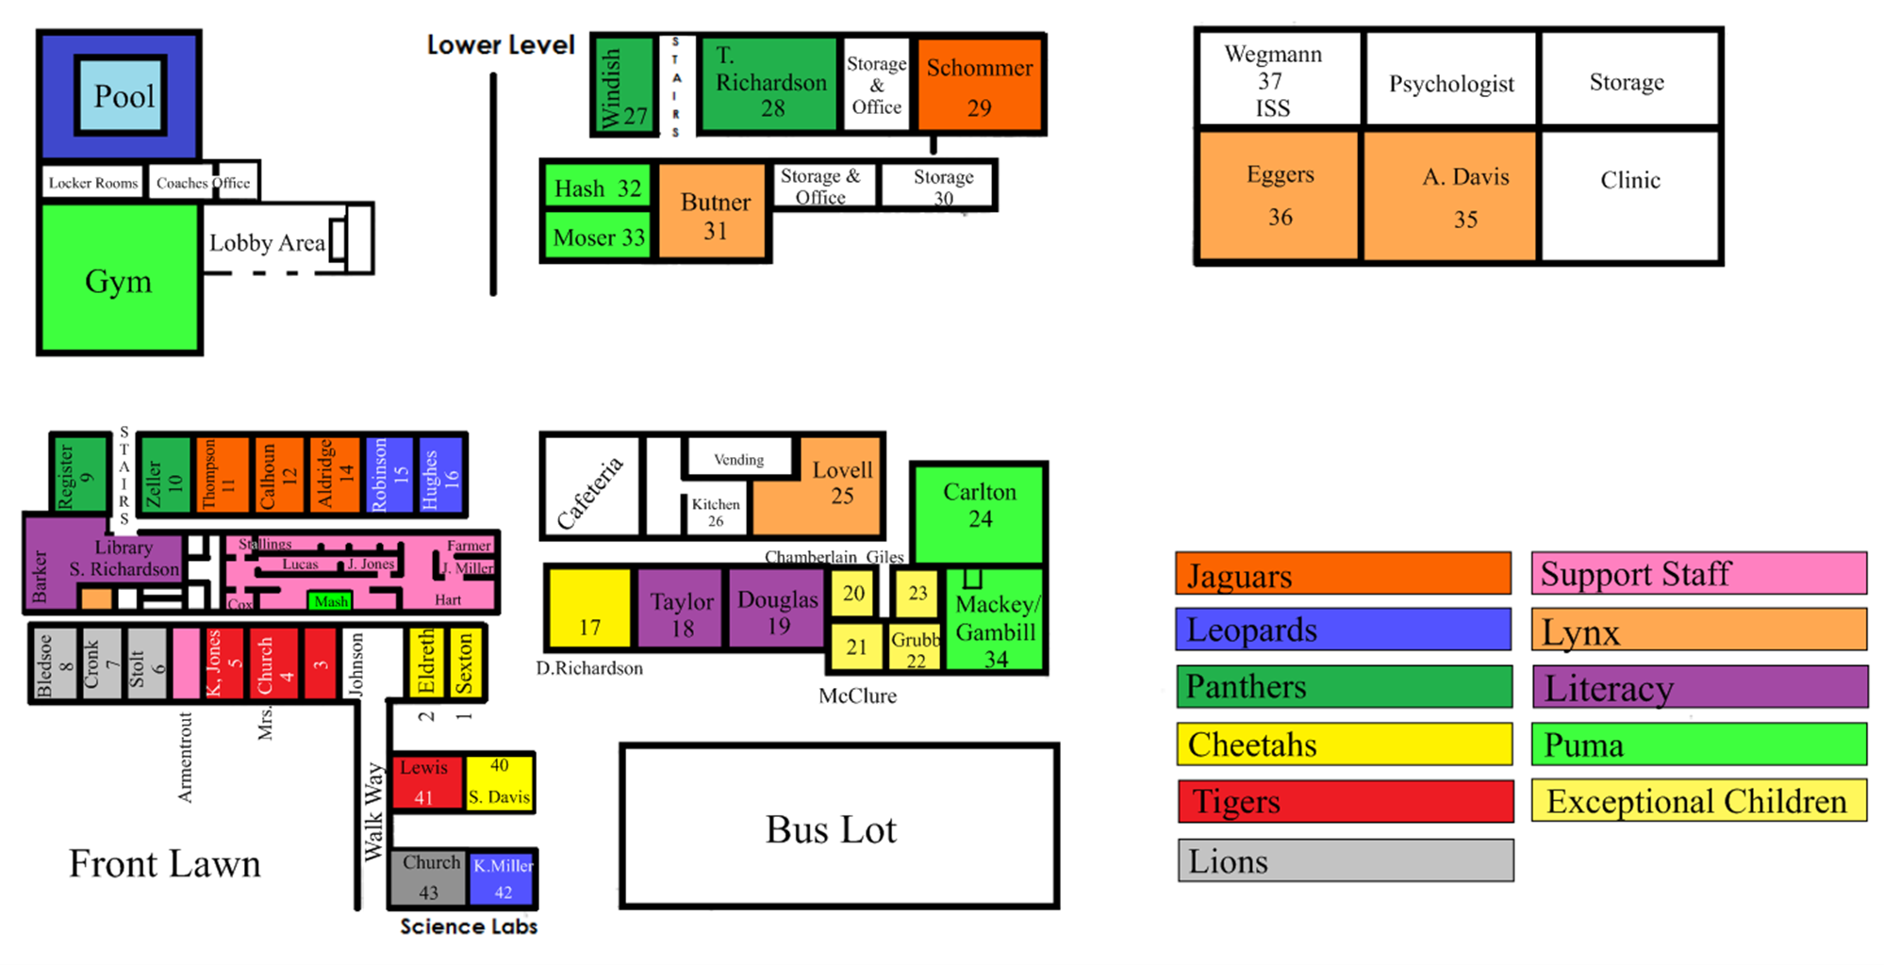

**Ashe County Middle School**

**2016-2017**

**7th Grade Registration**

Name: _________________________________________________________________________________

First Middle Last

Student #______________________

Address: _____________________ Contact # _____________________

_____________________ Sex: M F

Date of Birth: _________________

Elementary School attended: _________________________________________

Parent(s)/Guardian Signature: _________________________________________

**Required Classes**

Math Social Studies

Language Arts Health & PE (1 semester)

Science

**Encore Choices**

*7th grade students have the option of taking 1 semester of band (fall only) or 2 semesters of band to make a year -long course. Please make an X beside the box to indicate your choice. If you do not want to take band, leave the boxes blank.*

______________1 Semester Band or ______________Year-Long Band

*7th grade students also have the option of taking 1 semester of chorus or 2 semesters of chorus to make a year-long course.* *Please make an X beside the box to indicate your choice. If you do not want to take chorus, leave the boxes blank.*

_____________1 Semester Chorus  or ______________Year-Long Chorus

***Students cannot take both band and chorus.***

*Students not taking band or chorus will automatically take the Rotational Classes for 9 weeks each. Please make an X in the box to indicate you wish to take Rotational Classes. Students will take all classes listed under Rotational Classes if they choose this selection.*

_____________Rotational Classes

Art Exploring Career Decisions Agriculture

Spanish Project Lead the Way Business Technology

***Please return your signed registration form to your teacher by .***